Gough Group

<Additional User Access in NAXT>

<15.02.2018>

<Version 1.0>

**Document Control**

**Version**

|  |  |  |  |
| --- | --- | --- | --- |
| **Version** | **Date** | **Author(s)** | **Description of Change(s)** |
| 1.0 | 15.02.2018 | Diane George |  |
|  |  |  |  |
|  |  |  |  |

**Related Documents**

|  |  |  |
| --- | --- | --- |
| **Document Title** | **Document Location** | **Date** |
|  |  |  |
|  |  |  |
|  |  |  |

**Document Purpose:**

Learn how to Trace existing roles to give users additional access to functionality in NAXT.

# NAXT users requesting additional access

## First find out what action they are trying to do by performing a Trace

**Security information needed for the Trace**

In the *GGNZ* navigation bar,

**Select** *System administration*from the dropdown menu

**Expand** *Security* from menu box

**Select** *Security entry point positions*

(This opens the *Tracing Recording window*, keep it open but minimise to avoid using until you need it later in this process)

In *GGNZ*,

**Navigate** to the point that the user is trying to access

(Example: *GGNZ/Inventory and warehouse management/Journals/Item Counting/Counting from a journal*)

**Click** *Lines*

**Filter** the *Search results* to only show *CYCLECOUNT*

Before continuing the process, open the *Security entry point positions window* again

**Click** *Start recording*

**Return** to the *GGNZ window that has the Lines window* activated

**Click** *Create/On-hand*

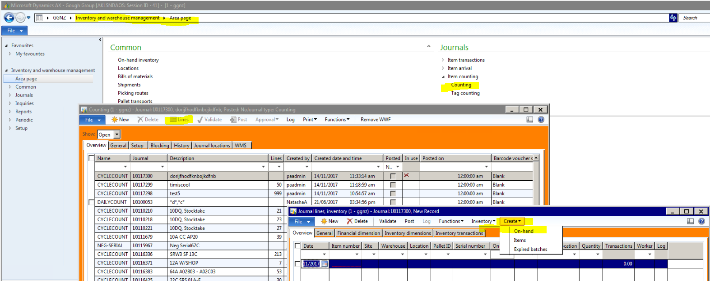

**Click** *OK button*

(This may take a little while to respond.) **Close** the *Infolog* that opens automatically.

**Return** to the *Security entry point positions window* again

**Click** *Stop recording*

**Note** the *Entry Point Name*

*(*Example: *InventCountCreate, Entry point names* may vary)

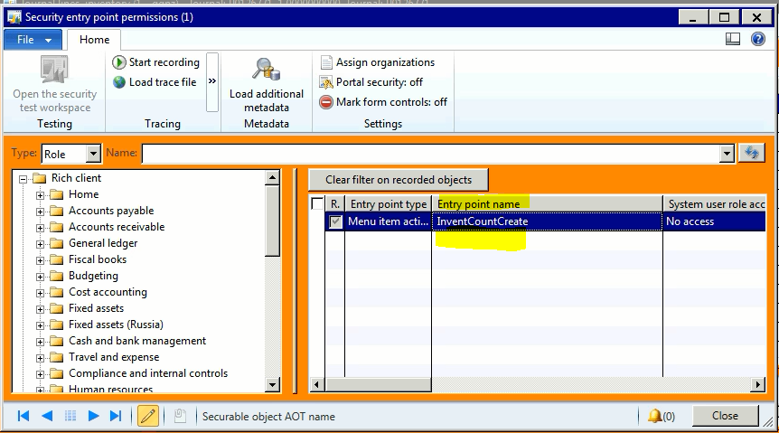

**Open** this link to the [Live XLS Security Document](https://goughgroupltd.sharepoint.com/:x:/s/emerge/EW4hpYk_wppJvnZ_ObjJLzYBW0qJGd2EIM0kkkISdM23yQ?e=4%3aSRdBhL&at=9)

**Click** *Get data icon* to make sure you have the latest version

**Ensure** all Filters have been removed

**Select the following only**

*Sec Object Name*: (in this example it’s *InventCountCreate*, it may vary from call to call)

*Developed by role*: “GOUGHS”

(*Example* of Selected results: showing the three columns)

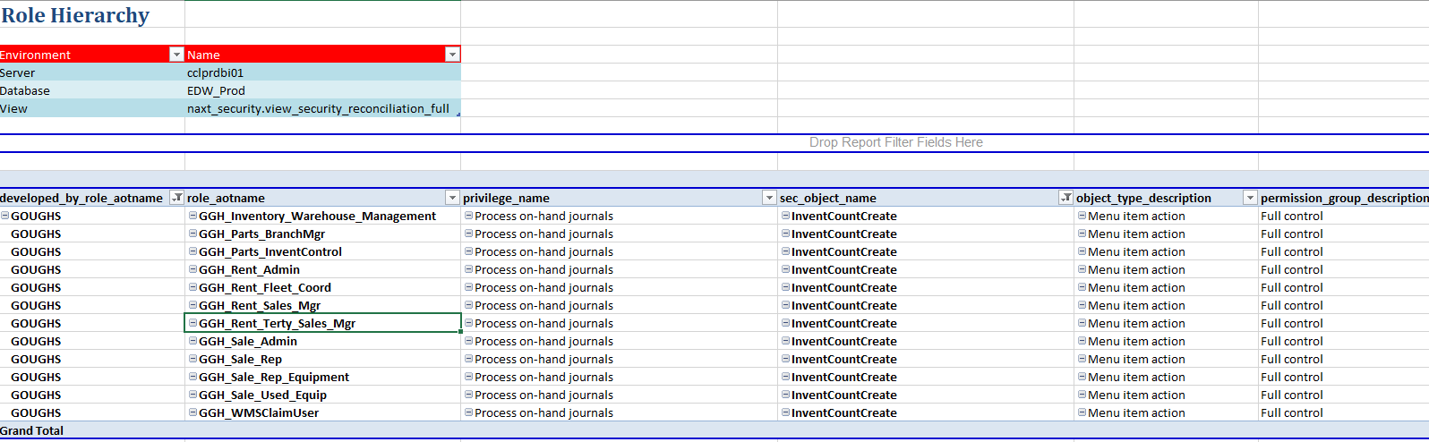

**Create** a new MSWord document as you are required to send the security access request with the following information to David Duff (Security Administrator) for their approval.

**Include the following information**

Name of the person who needs additional access

Name of their Manager

Screenshot of the button they would like to click

Entry point that was established above

Suggest a possible Role name that would be a good fit (by logic and optional)

Once the security team has approved grant the role to the user and reply to the person’s manager and advise that the employee has been granted access.